Clear and Concise Title of the Paper Must be There With 4 and Above Letter Words Capital: No Other Formatting

First name, second name of second author
First name, second name of second author
First name, second name of third author
Abstract

Abstract must be of 150-200 words. It must include infomration about the purpose of the study, research design and method, population, sample and sampling technique. The research instrument, its validity and reliability must be briefly stated here. Brief information about data collection and data analsysis techniques must be added. One or two major results and recomnedations of the study must also be included in the abstract. Include brief information and avoid unnecesary deatils. Introduction and importance of the study is not required in the abstract.

Keywords: 4-5 keywords, authors’ guidelines, relevance to sudy, avoid ‘and’, avoid 'or’

Introductıon
Introduction is an important and the first detailed section of the paper. Its purpose is to explain the background and importance of the study. You can explain the rationale of the study and statement of the problem in this section. It also explains the research gap that the study was designed to fill. Introduction must be based on up-to-date research papers and reports in the field of the study. This information should ideally be presented in the ‘funnel’ form, following from general background to specific background of the study.
Introduction consists of about 400-500 words (almost one and half page of this template). In the start of a new paragraph, a space of five letters is given. The authors are requested to check the article thoroughly for spellings, references, figures, and illustrations, etc., before sending for publication. A well-written introduction explains the information in a systematic manner. An effective introduction speaks to the reader. Please do not delete any space from this template.

Literature Review
Literature review of the research article covers the details on what has been written and researched on the current subject or topic. It also intends to identify any interpretable trends or patterns in the literature related to the current study. It aggregates the empirical findings related to specific research objectives/questions of the study. You can explain operational definition of the variables related to your study here. Literature review must be based on latest research papers, reports, books and other resources. In-text citation of all the resources must be cited according to APA style (6th Edition).
Length of the review literature
Literature consists of about 850-950 words (almost two and half pages of this template). You can add headings in the review literature in the format (bold, italic with font size 12) as given above. Avoid adding too many headings. Make sure that all paragraphs are of appropriate length and there is a logical flow of information from one paragraph to another. Avoid paragraphs with only one, two or three sentences. Please check the article thoroughly for language, spellings, figures, and illustrations, etc., before submission to the OJS platform of the journal.

Theoretical Framework
You can explain theoretical and/or conceptual framework (whichever is applicable) of the study in this section. Theoretical framework can be of 300-500 words (almost one page of this template). You can add figure/diagram of your study framework with appropriate citation. A sample figure is given below for reference.

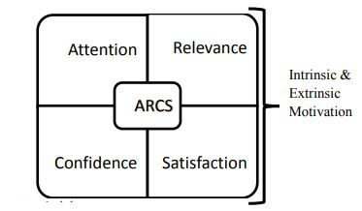
Figure 01. Theoretical Framework of the Study (Keller, 1983)

Research Objectives/Questions
The research objectives of the study are given below:
- To analyze the effect of variable x on variable y in z context.
- To interpret the practices of A for managing B tasks.

Methodology
Research methodology must include details about the research design, research method, population, sample, sampling technique, research instrument and its validity and reliability, data collection and data analysis of the study. In case of mixed-methods research design, details of above-mentioned components may be given in a systematic manner. In case of experimental research design, the information related to the learning content for the experiment and, external and internal validity threats to the experiment must be given in this section. The information related to research ethics and privacy of the research data may be briefly mentioned here.

Findings
This section includes the interpretation of the output of data analysis. The output of data analysis may be presented in the form of tables and figures with clear and relevant captions for the tables and figures. Include the study results in this section keeping in view the research objectives/questions of the study. Avoid including too many or unnecessary tables/figures of the data analysis, here. Make sure that this section shares the study results in a clear and concise manner. The interpretation of the study results must be added after each table and figure. If your study involves hypotheses, it must involve use of inferential statistical techniques. Please clearly mention about the status of the hypothesis in the interpretation below the relevant table. JECCE follows APA style (6th Edition). Some sample tables are given below to give you an idea of the format. Delete the table which is not relevant to your study. Avoid copying and pasting directly from the SPSS output file.

Table 01
Descriptive analysis
Factors of A | Mean | Std. Deviation
a | 5.24 | .94
b | 4.78 | .97
c | 4.89 | .83
d | 4.83 | 1.03
e | 5.02 | .94

Table 01 reported the mean score and standard deviation of factors of A. It is evident that all the respondent were strongly agreed to the factors. You can add here the interpretation to explain all the important results mentioned in the table 1. Selection of Table/figure will depend upon the statistical test used for data analysis or the nature of data to be reported. You can add sub-headings in this section and mention the hypothesis above the table (if applicable). For more guidance about the design and format of tables and figures, you can visit the link here (See this link for formatting of data tables for various types of analysis: https://apastyle.apa.org/style-grammar-guidelines/tables-figures/sample-tables#demographic) and here (https://apastyle.apa.org/style-grammar-guidelines/tables-figures/sample-figures).
Effect of Variable A on Variable B
Independent sample t-test was used to determine the effect of variable A on variable B, as give in table 2. This text is given to give you an idea about the format of the sub-headings. An figure is given below to give you an idea about the format of a figure.

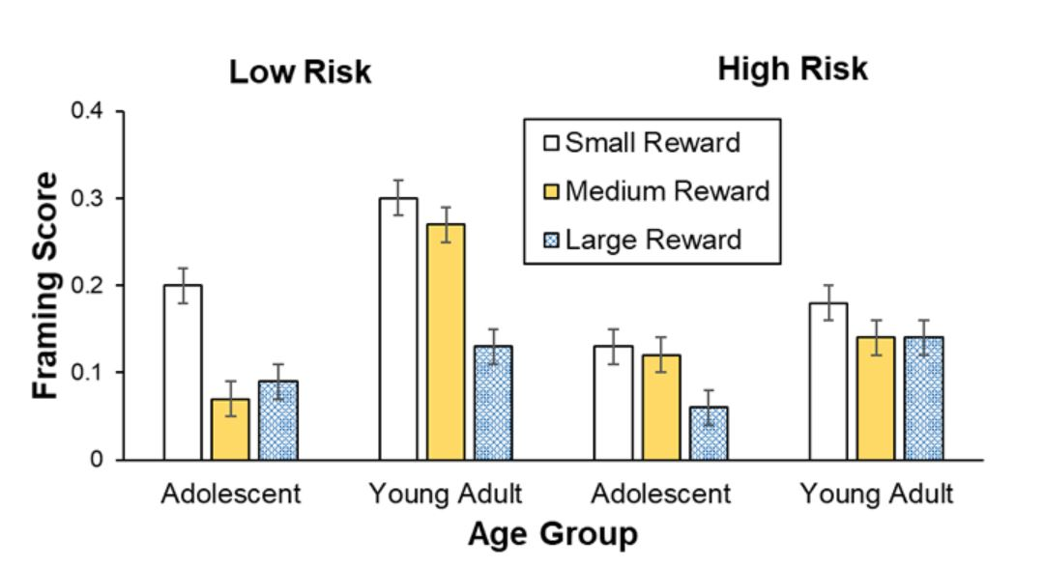
Figure 2. Framing scores of adolescents and young adults with respect to awards

Figure 2 showed the framing scores of adolescents and young adults with respect to small, medium and large rewards. According to this graph, young adults have the highest framing scores with respect to small, medium and large rewards.

Discussion
Discussion section explains and evaluate the results of yoru study showing how it related to the results of studies in the literature and building an overall argument about the results of your study. You are not required to discuss all of your study results but the major study results keeping in view the research objectives/questions, must be discussed in the context of results of related research studies within and/or outside the country. Focus to include latest research work in this section. Discussion can be upto 300-400 words long (almost 01 page of this template). You can add paragraphs in this section but make sure that there is a logical connection and flow of argument across various paragraphs.

Conclusion
Based on the research objectives/questions and findings of the study, precise and clear conclusion of the study must be stated here. You can explain the conclusion of the study in one or two paragraphs. The conclusion must be stated in such a way that a general audience can understand it. There is no need to restate the study results or any numerical value. Keeping in view the study resuts and numerical values stated in the findings section, write your conclusion in the form of paragraph in this section. The conclusions should be very precise and answering your research questions / research objectives.
The recommendations of the study must be the last paragraph of the paper. It must be based on the study results. It can be the suggestions for improving the practices in future or for further research work required in this field. It must be stated keeping in view “who will do it?”, “what they will do it?” and “how they will do it?”. Avoid giving vague or general suggestions. The word limit for a complete article is 4500-7000 words. Annexures/appendices are not required unless deemed essential as a requirement. JECCE reserves the right to update the paper template and guidelines from time to time. The author(s) is required to follow the guidelines given in this template or shared otherwise in order to process the paper for further stages.
Contribution to the Field: you can explain in this section that what are unique contribution of your study which was not present in the existing literature.

References
Addison, R., & Brundrett, M. (2008). Journal article on motivation and demotivation of teachers in primary schools: the challenge of change. International Journal of Primary, Elementary and Early Years Education,36(1), 79-94. doi:10.1080/03004270701733254
Ahmad, M. (2011). Thesis work on effect of problem-solving teaching strategy on the performance of 8th grade students (Unpublished doctoral dissertation). Institute of Education and Research, University of the Punjab, Lahore.
Badri, M. A., Mason, S. E., & Mourad, T. E. (2010). Conference paper on determinants of parent’s satisfaction with subjects taught and the effects of school factors, parent’s demographics and school’s characteristics. Abu Dhabi: Abu Dhabi Education Council. Paper presented at the International Academy of Business & Public Administration Discipline‐2009 annual conference, Dallas, TX, USA. April 23‐27, 2009.
Bano, M. (2008). Document from a webpage on public private partnerships (PPPs) as ‘anchor’ of educational reforms: Lessons from Pakistan. UNESCO Report No. 2009/ED/EFA/MRT/PI/12. Available on http://unesdoc.unesco.org/images/0017/001780/178017e.pdf
Creswell, J. W. (2009). Book on research design: Qualitative, quantitative, and mixed method approaches (3rd ed.). Los Angeles: SAGE Publications.
Webpage address of Journal of Early Childhood Care and Education. (n.d.). Retrieved from http://jecce.aiou.edu.pk/?page_id=23

How to cite the article in APA:
Lastname, Firstname & Lastname, Firstname. (2023). Clear and concise title of the paper must be there with 4 and above letter words capital: No other formatting. Journal of Early Childhood Care and Education, 10(2), 1-7.

NOTE: Manuscripts should neither be less than 4000 words nor exceed 7,000 words, including abstract, references, tables and figures.

Corresponding author (mention it before the designation in front of first, second or third author whichever is applicable for your paper), Designation, complete name of the institution, city, country. Email: first_author_name@email.com; ORIC ID
Designation, complete name of the institution, city, country. Email: second_author_name@email.com; ORIC ID
Designation, complete name of the institution, city, country. Email: third_author_name@email.com. ORIC ID

